Mamp pro

1. What is MAMP PRO?

MAMP PRO is a configuration application that helps you set up and run the Apache web server and the MySQL database server. It also takes care of the configuration of different versions of PHP. It is the big brother of the free MAMP application. Both applications need the MAMP folder to run.

**Note:** MAMP PRO stores its databases in a different location than the MAMP application.

Translate:

1.什么是MAMP PRO？

MAMP PRO是一个配置的应用程序，可以帮助您设置和运行Apache Web服务器和MySQL数据库服务器。它也需要不同版本的PHP配置的照顾。它是免费的应用程序MAMP的大哥哥。这两个应用程序需要MAMP文件夹中运行。

**注意：**MAMP PRO存储它的数据库在不同的位置比MAMP应用。

## 2. Installation

### 2.1 Installation requirements

To use MAMP PRO, your system must meet the following requirements:

* A working MAMP installation (MAMP can be downloaded directly with the MAMP PRO installation package).
* Apple OS X, version 10.6.6 or later.
* A Mac with a 64-Bit-capable CPU.
* A user account that is part of the Admin Group. Go to Preferences > Users & Groups to confirm this.

### 2.2 Installing and upgrading MAMP PRO

* Download MAMP PRO from [https://www.mamp.info](https://www.mamp.info/).
* Double click on the MAMP_MAMP_PRO_3.0.pkg file in your Downloads folder.
* The System Installer will guide you through the installation process.
* If the installer detects an existing MAMP folder it will rename the current MAMP folder to MAMP_current_date.
* An existing "htdocs" folder will be moved to your new /Applications/MAMP folder.
* Confirm that all data has been transferred correctly before starting MAMP PRO.
* Your /Applications/MAMP_current_date folder can now be deleted. You may however keep it, so you can fall back to your original setup.

**Note:** You need administrator permissions to install MAMP PRO!

### 2.3 Uninstall

Use the MAMP PRO Uninstaller located in /Applications/MAMP PRO to remove MAMP PRO.

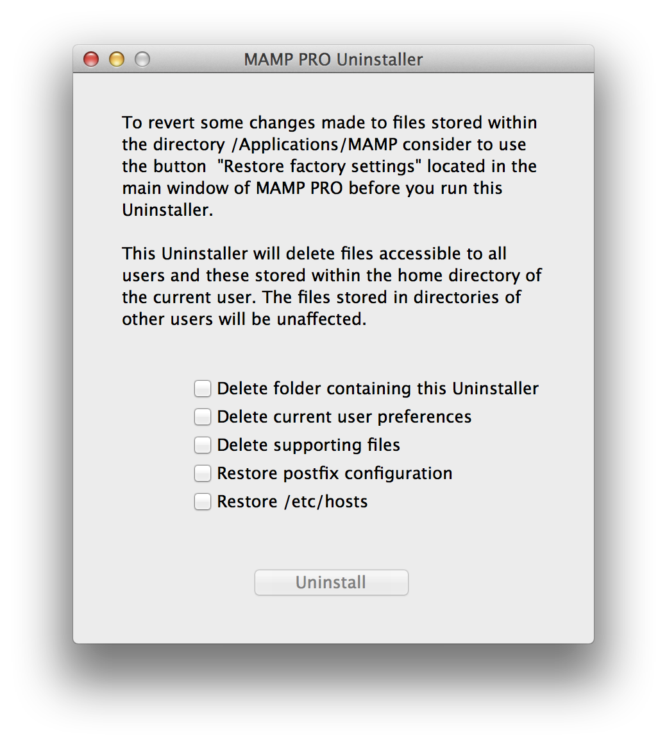

Drag the /Applications/MAMP folder to the Trash to complete uninstallation.

Translate:

2.安装

2.1安装要求

* 要使用MAMP PRO，您的系统必须满足以下要求：
* 一个工作MAMP安装（MAMP可以直接与MAMP PRO安装包下载）。
* 苹果OS X，10.6.6版本或更高版本。
* Mac计算机配64位功能的CPU。
* 这是管理员组的成员用户帐户。转至首选项>用户和组证实了这一点。

2.2安装和升级MAMP PRO

* 从https://www.mamp.​​info下载MAMP PRO。
* 双击你下载文件夹中的文件MAMP_MAMP_PRO_3.0.pkg。
* 该系统安装程序将引导您完成安装过程。
* 如果安装程序检测到现有MAMP文件夹将重命名当前MAMP文件夹MAMP_current_date。
* 现有的“htdocs目录”的文件夹将被移动到新的/应用程序/ MAMP文件夹。
* 确认所有的数据已开始MAMP PRO之前正确传输。
* 你/应用程序/文件夹MAMP_current_date现在可以删除。不过，你可以留着吧，这样你就可以回落到原始设置。

**注意：**您需要管理员权限才能安装MAMP PRO！

2.3卸载



使用位于/ Applications/ MAMP PRO的MAMP PRO卸载程序来删除MAMP PRO。

为/ Applications/ MAMP文件夹拖到废纸篓完成卸载。